# **Overview**

This section should give a basic overview of the project and the team(s) behind it. An overview should include:

* + **About our team**: Our team consists of 6 members. In the lesson, we discussed and decided that we will do the project all together, because, firstly, it will not take much time and, secondly, there will be no problems of mutual understanding. We created a chat in team and telegram to discuss and throw off all ideas for design, codes, various photos through a screen demonstration.
  + **Members and their rules.**
  + **Galymov Makhambet (**[**201263@astanait.edu.kz**](mailto:201263@astanait.edu.kz)**):** Leader Makhambet organized the preparation time and divided the work to the members according to their ability. He helped all members of the group on different problems. Completed the template documentation
  + **Arysbay Dastan (**[**201672@astanait.edu.kz**](mailto:201672@astanait.edu.kz)**):** Dastan made an initial version of the main page. Added a contact footer linking to university accounts. Also helped the development of the menu, adding a navigator and carousel using bootstrap. Made the final version of the homepage
  + **Askarbek Akzhurek (** [**201457@astanait.edu.kz**](mailto:201457@astanait.edu.kz) **):** Akzhurek made the final version of the menu page. Also helped the development of other pages, worked with bootstrap grid, navigator. Worked with bootstrap carousel
  + **Konay Aruzhan (**[**201811@astanait.edu.kz**](mailto:201811@astanait.edu.kz)**):** Aruzhan made the final version of the Reservation page. She worked with Mailchimp to create a registration form. When a customer fills out the form, his details will be displayed in her Mailchimp account. Also helped the members with some problems
  + **Satybaldy Balnur (**[**201548@astanait.edu.kz**](mailto:201548@astanait.edu.kz)**):** Balnur helped the group members choose a photo. I also wrote a description and prices of the dishes. Helped with website design.
  + **Mukangaliyev Alisher (** [**201812@astanait.edu.kz**](mailto:201812@astanait.edu.kz) **):** Alisher helped the members of the group with different designs and colors. Also made photoshop for various photos. His choice helped us make the site more attractive
  + **Communication strategy** – Every day in the evening we were engaged in projects after school for 0.5-1 hours. Also gathered at the university and shared ideas
* **Motivation** – This project is designed to help students choose and book meals from university canteens. During this project, we were able to further improve our knowledge and exchange experiences.
* **High-level project scope** – It’s a complete website overhaul.
* **Target audience/market** – Naturally, our audience considers only AITU students. Because according to quarantine measures, no one can enter from outside the university.

# **Project goals and team interests**

Our site was created for the canteen of our university. Our goal is to make the site more interesting and attractive, so that their clients are not only AITU students, but also from outside. But now, in difficult times for us, they hinder this business from developing. But we believe they need a shipping method for development.

Team interests

* Understanding HTML tags and CSS by creating a website dedicated to our dining room.
* Establish a solid understanding of website design principles
* Improve team working skills by collaborating with different members of the group

# **Phases**

* Bootstrap grid
* Bootstrap carousel
* Body divs
* Bootstrap navigator
* CSS style
* HTML code

# **Content structure**

**Site map**

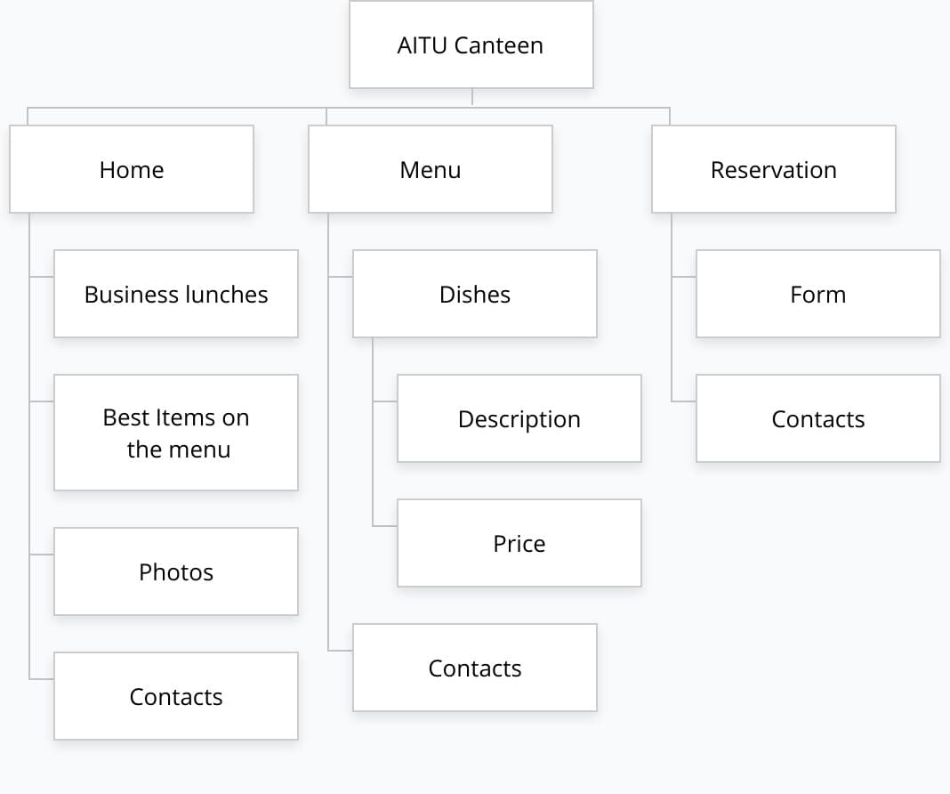

**Content types**

* **Home**
* **Menu**
* **Reservation**

**Design**

Our site turned out to be quite so beautiful. To do this, we first looked at many dining sites to find out which colors to match, how to combine them correctly. But our main task is that the client felt this atmosphere at home. At first glance, the site design is interesting. There is a main page, a menu and a registration for a reservation. And on the main page there are different boxes and combos with price tags, a lot of photos, they were taken from the Internet because they did not have time to take a picture of ours, and the canteen's contacts.

**Functionality**

As I said before, ours consists of three sites. One of them is "Reserve". It includes items such as "First Name", "Last Name", "Phone Number", "Email Address", "Date", "Time", "Number of Visitors" and "Reviews". It is obligatory to replenish all points, except for "Reviews". If you do not replenish, then accordingly it is impossible to send a request for a reserve.

**Hosting**

We used the Facebook, TikTok and YouTube pages for hosting and placed them in the contact area, in the footer. For this we have used this template: <a href="" target="" class=""> </a>. The href attribute specifies the link's destination, here we used url of hosting page. The target attribute specifies where to open the linked document. So, inside of "target" we used "_blank", because this value opens the linked document in a new window or tab. Also, we used class to make add a gesign in css.

**Accessibility**

As with any website, our goal is to attract as many customers as possible and to be comfortable. We used big bold fonts for product descriptions etc. We tried our best to make the design of the site similar to the design of the dining room, so that the client was pleased. Basically, it plays the role of color, for example: bright greens, yellows, reds and others. And so that they fit together. For this, new web technologies were used.

**Deadlines**

We did everything together in 1,5 day.

Saturday night and Sunday

# **Summary**

**This wonderful site was created for our project. We chose the canteen of our university. As planned, the site turned out to be more beautiful than expected, we invested what we could, and we are very pleased with the result. But there were some difficulties with other lessons, and with problems with entering the university outside of school hours. There were a lot of mistakes in working with the code, but with each time spent on creating this site, we gained experience. The goal of this project is to gain popularity and attract many clients. Of course, we took some photos of the dishes from the Internet and did not refuse that it was in our dining room. Thank you for the team project provided, it has brought us together very strongly, and we are happy to work together. Have we reached our goal? We will see this somewhere in a couple of months.**